Meetings In Agile
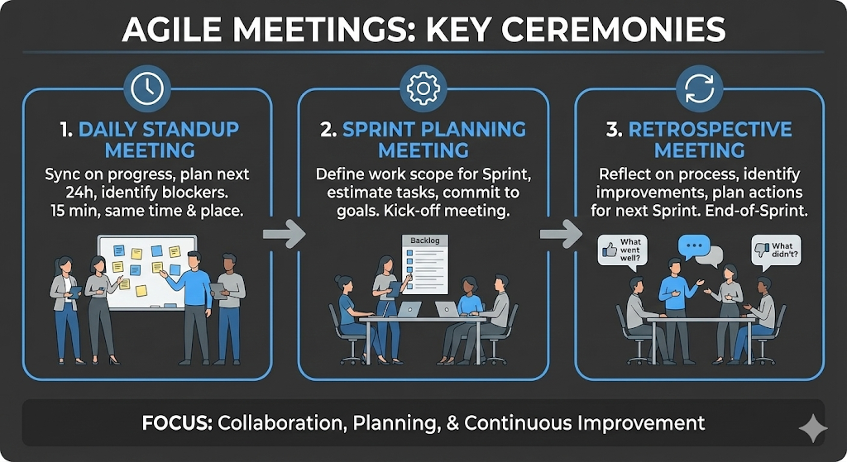

1. Daily Standup Meeting (The "Daily Scrum")
This is a short, 15-minute synchronization meeting held at the same time and place every day.
- Who: The Development Team, Scrum Master, and Product Owner (optional).
- The Goal: To align the team on the next 24 hours of work and identify any obstacles.
- The Structure: Each member typically answers three questions:
  - What did I do yesterday?
  - What will I do today?
  - Are there any blockers (impediments) in my way?
2. Sprint Planning Meeting
This meeting kicks off the "Sprint" (a set period of time, usually 2 weeks, to complete specific work).
- Who: The entire Scrum Team (Product Owner, Scrum Master, Developers).
- The Goal: To determine exactly what features or tasks (User Stories) will be built in the upcoming Sprint.
- The Structure:
  - The Product Owner presents the highest-priority items from the product backlog.
  - The team discusses the technical effort required for each item.
  - The team commits to a specific scope of work for the Sprint.
3. Retrospective Meeting
This is arguably the most important meeting for continuous improvement. It happens at the very end of a Sprint, after the work is finished.
- Who: The Scrum Team.
- The Goal: To inspect how the team worked together and find ways to improve the process for the next Sprint.
- The Structure: The team reflects on the past Sprint, usually asking:
  - What went well?
  - What didn't go well?
  - What actions can we take to improve next time?
1. What is Kanban?
Kanban (Japanese for "visual signal" or "card") is a workflow management method designed to help you visualize your work, maximize efficiency, and improve continuously. Unlike Scrum, which works in fixed time intervals (Sprints), Kanban is a continuous flow model.
- The Goal: To reduce the time it takes to get from the start of a task to the finish (Cycle Time) by balancing the work with the team's capacity.
- Key Rule: Limit Work in Progress (WIP). You focus on finishing current tasks before starting new ones to avoid bottlenecks.
2. What are Lean Principles?
Lean is the philosophy that gave birth to Kanban. It originated in manufacturing (specifically the Toyota Production System) but is now used in software and business. The core idea is to create more value for customers with fewer resources.
The Key Principles of Lean:
- Eliminate Waste: Anything that does not add value to the final product (e.g., unnecessary meetings, waiting time, unused code) should be removed.
- Deliver Fast: Get the product to the customer as quickly as possible to get feedback.
- Build Quality In: Fix defects immediately rather than waiting for testing at the end.
- Respect People: Empower the team to make decisions.
3. What are Kanban Boards?
A Kanban Board is the physical or digital tool used to implement the Kanban method. It makes invisible work visible.
- Structure: It is divided into columns that represent the stages of your workflow. The most basic version has three columns:
  - To Do (Backlog)
  - Doing (Work in Progress)
  - Done (Completed)
- Cards: Each task is represented by a card.
- Flow: As work progresses, cards are moved from left to right.
- WIP Limits: You might see a number at the top of the "Doing" column (e.g., "Max 3"). This means the team cannot have more than 3 items in progress at once. They must finish one to pull in a new one.

